- PURCHASE ORDER RECEIPT PROCESS:
Purchase Order Receipt or Goods Receipt Note (GRN) process is having 3 steps in ERP. They are
- Receive
- Inspect
- Deliver

Receive and Deliver processes are performed by Stores where as Inspect is done by Quality Department.

- Receive
Receive step is for the recording the materials/services received from the suppliers. Receive step does not result in updation of stock.

Checks:
- Purchase order need to be in approved condition for making the receipt.
- Stores need to check the purchase order copy from ERP and supplier invoice copy for any variations in items,prices, taxes etc before entering the receipt,. If any variation found, they need to inform the same to purchase department for correction of the Purchase order. After making the receipt, if there are any changes to be done, we need to cancel the receipt to make the changes in purchase order and make the receipt again.
- If the receipt is an import, all the import taxes need to be updated in the PO, BOE invoice is to be created and paid in Accounts payables and Currency conversion for the current month also needs to be updated for imports before the Receipt is entered.
NAV: WIL India Local Inventory End User India Localization Receiving Receipts (Localized)

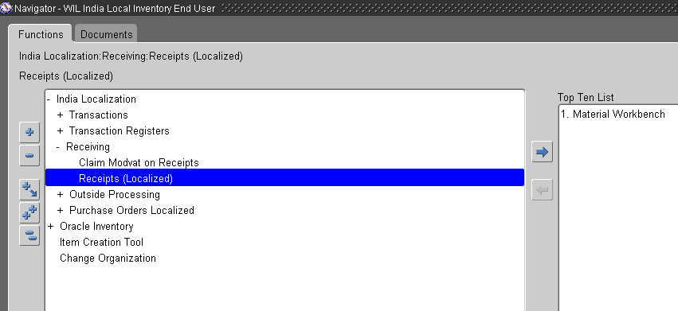

- Click on New button to create the New Purchase order receipt.
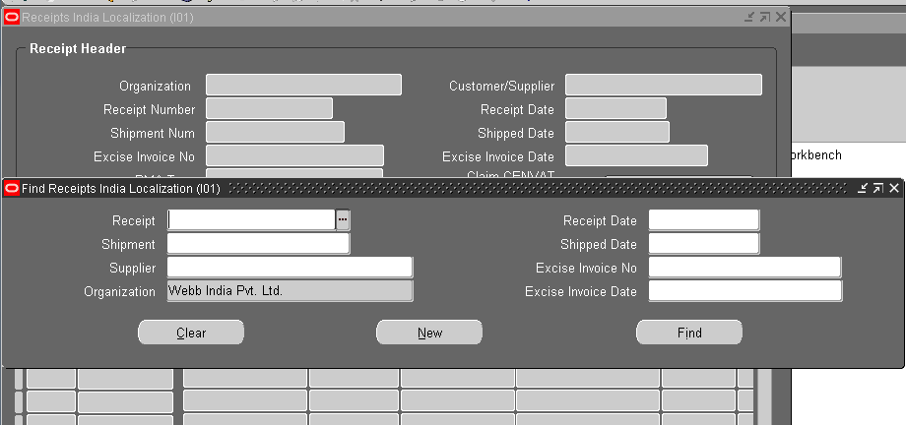

- Enter the Purchase order number and click on find

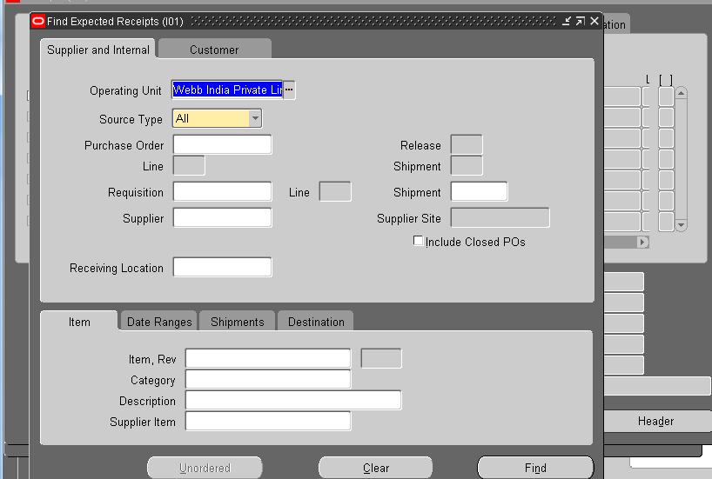

- There are two options available here, one is to create a new receipt and another one for adding items to the existing receipt.

- If you choose ‘Add to Receipt’ option, system will ask for the any existing receipt number and you need to select the receipt number for adding items to it. Other fields like Supplier invoice number, date, DFF values etc, all will get defaulted automatically and is not required to enter again.

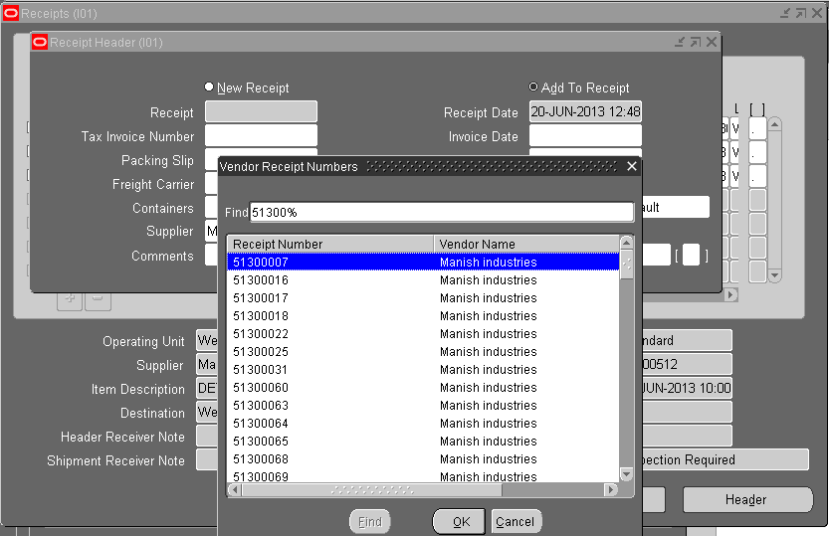

- If you choose new Receipt, you are newly creating a receipt. Receipt number is an automatic sequence number, which gets generated when the receipt is saved. Need to enter all the fields like Tax invoice number, date in the receipt header area. Some more fields are available in DFF, where gate entry number, date, tax cum DC number etc fields need to be filled.
Checks:
- Need to enter all the fields that are applicable. Many of the fields are taken to be displayed in report s so, if left out blank, they do not show up in reports.
- The value for “Routing” should be “Inspection required” for all material receipts. If any other value is present like “Direct Delivery” or “standard Receipt”, please do not save the Receipt and inform to purchase department for correction.
- For import GRNs, Currency conversion needs to be entered before making the GRN. If currency conversion is not given, system will throw an error for the same and does not allow saving the Receipt. Please approach accounts department to update the currency conversion.
- The fields which are visible in Yellow color are mandatory and receipt cannot be saved without entering data in these mandatory fields.

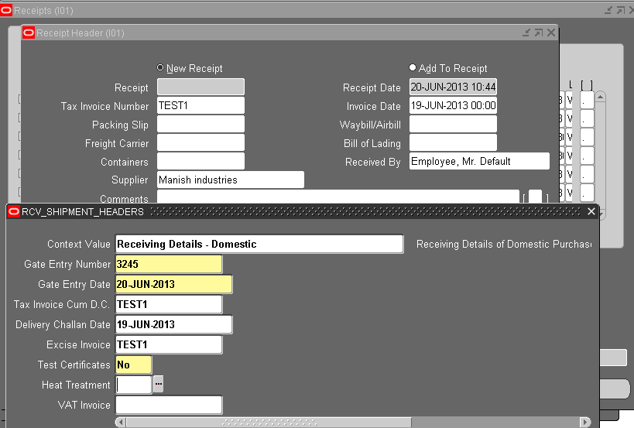

GO to receipt items area. All the items with quantities that are in the PO are displayed here and if any material is received partially, only the remaining quantity is displayed.

- Select the lines to be received based on the supplier invoice and enter the quantity and save.

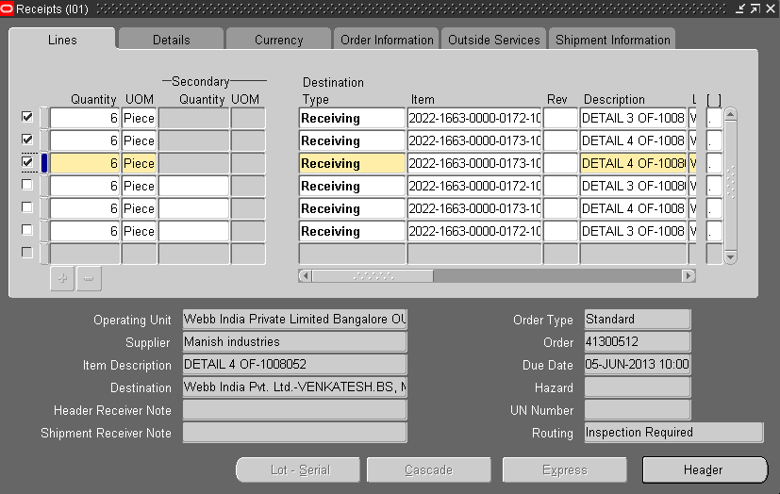

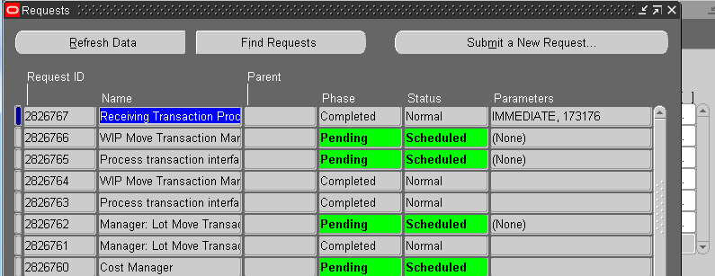

- When you save the Receipt, it generates an automatic sequence number and you can see the same in Receipt Header.
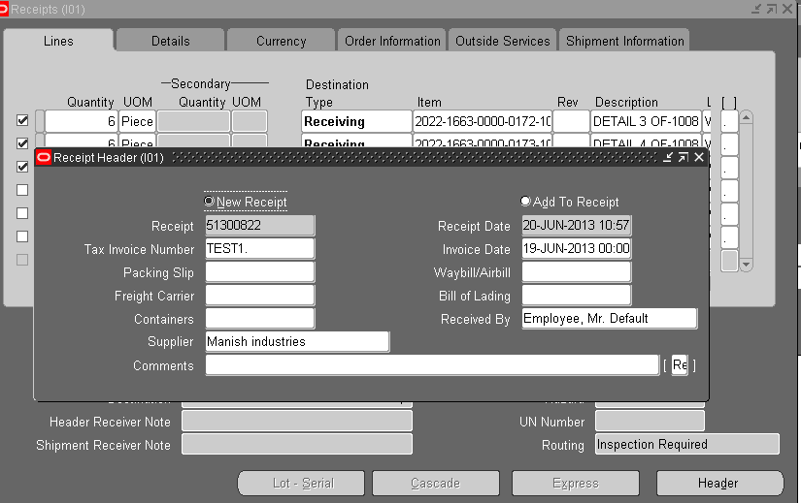

- Close the receipts form and click on refresh button on the Receipt header India localization page.
This refresh results in updation of the items we have received in the localization page.
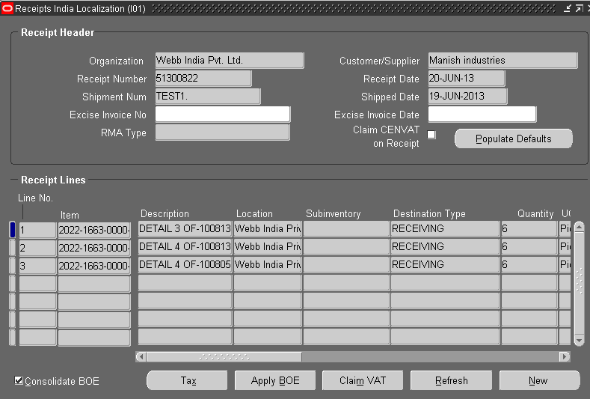

- Go to Actions and select “WIL Receipt Report”. This report is run using the receipt number and we can check the output in the Report output. Please note that the report is run automatically when you select the WIL receipt Report, we don’t need to run it manually.
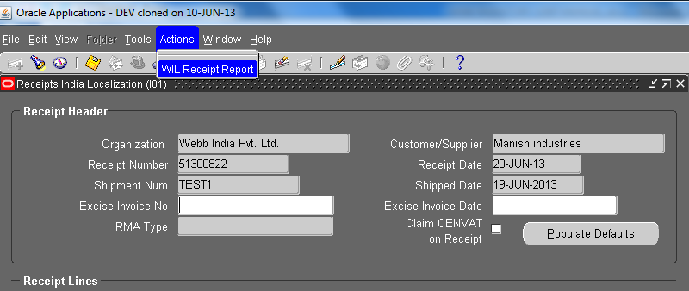

- Go to Requests and find the Request name “WIL Receipt Details” and click on output.
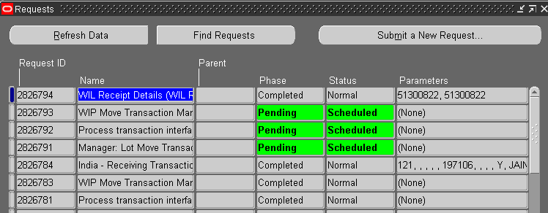

- We can verify the amounts in the report output with respect to supplier invoice values. If any variation , close the application and inform to purchase department for the variations.
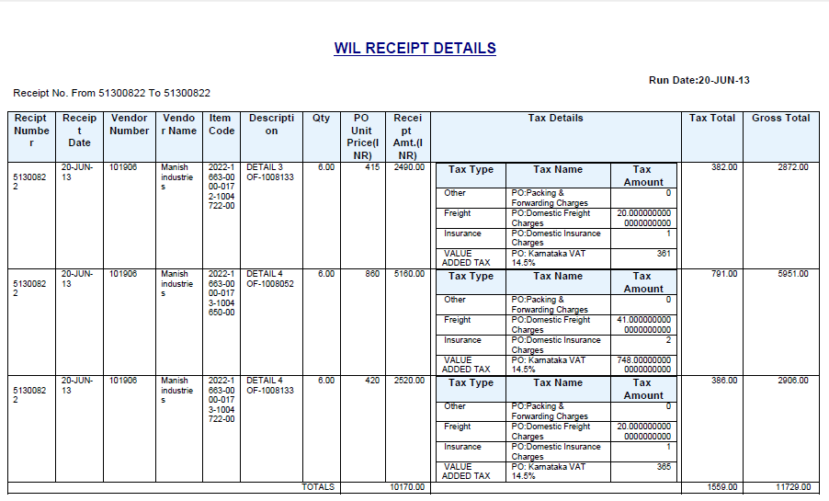

- If the supplier invoice and receipt amounts are matching, we can proceed for cenvat claim (if excise taxes present).
Enter the Excise invoice number and Date , click on claim cenvat on Receipt and click on Populate Defaults. These values get defaulted to all the items present in the receipt.
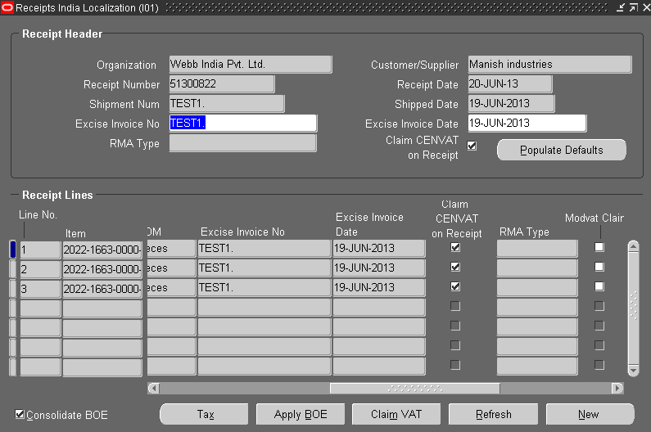
- If you want to update any adhoc taxes like freight or insurance, we can open the tax screen and enter the values.
Click on Apply and save if any tax changes are made. Third party vendor site need to be updated for third party taxes like Freight and insurance .
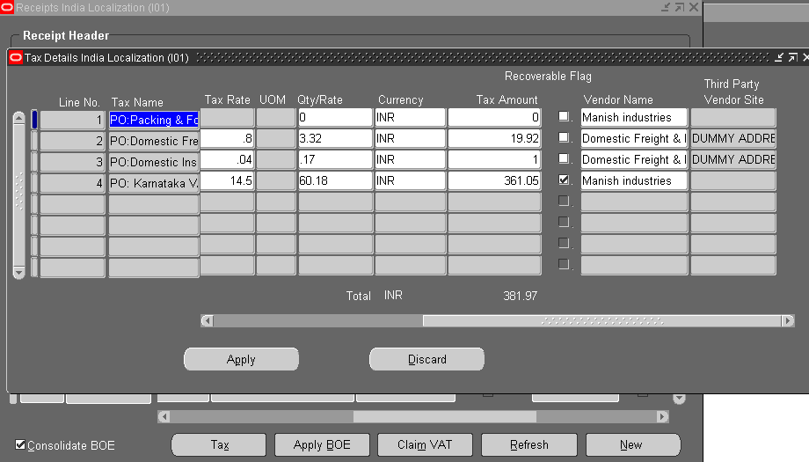

- Close the receipt screen and system populates a message shown below. Closing the receipt does not further allow modifications to the taxes, so any tax updations have to be done prior to the closing of the screen.
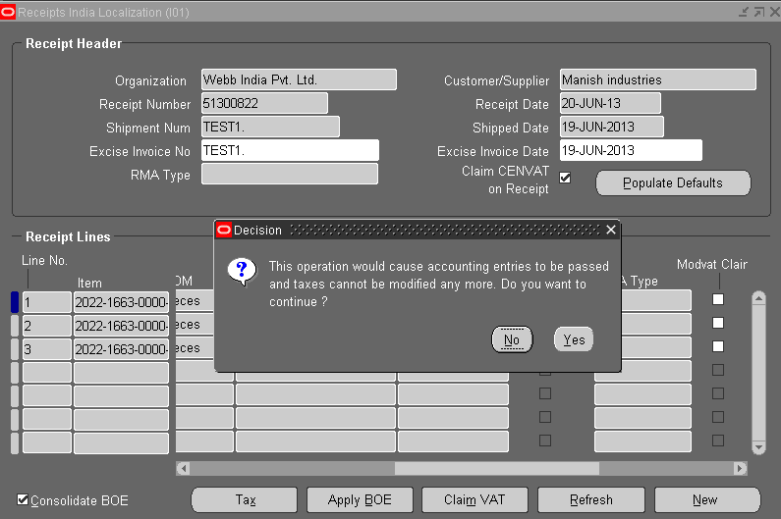

- IMPORTS: For import Receipts, Apply BOE is the additional process to be performed during receipt.

CHECKS:
- When you open the taxes screen, check for any missing taxes and inform to purchase department for taxes updation.
- In taxes screen, third party vendor site need to be added for third party taxes like Freight , insurance etc.
- BOE amount should be applied exactly the same amount as what is shown in total custom duty field. If any shortage of amount, system does not allow you to process and you need to inform the import department for modifications.
- If custom taxes are there, system does not allow closing the receipt without applying the BOE.
- BOE invoices will not be displayed unless payment of BOE is done in Account payables module, so, if any BOE invoice is not displayed, ask accounts to check the payment status of BOE invoice.

- Click on ‘tax’ button and check for any third party taxes are there , if exist , enter the vendor site and apply and save.
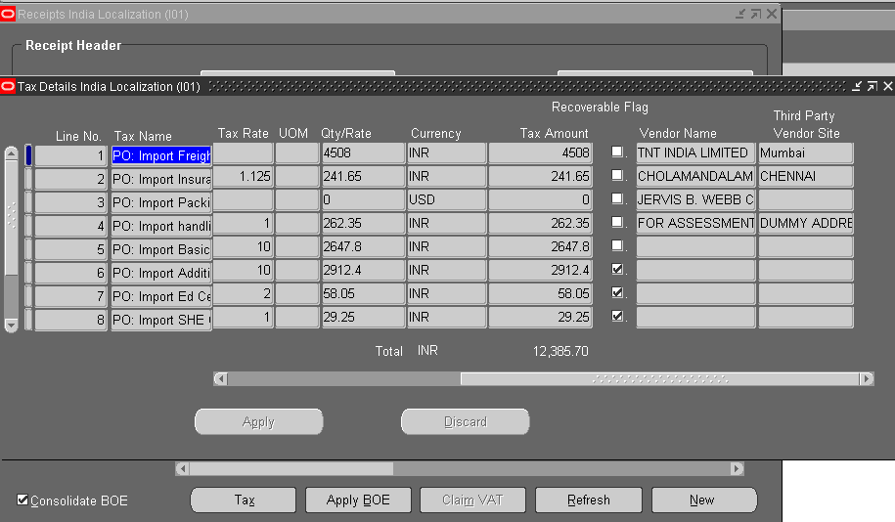

- Select each line and Click on the “Apply BOE” to enter the BOE amount.
All the Open BOE invoices are displayed in this screen and we need to apply BOE for each line taking reference of the total custom duty displayed. Enter the custom duty amount in the ‘amount to apply’ field and click on save.

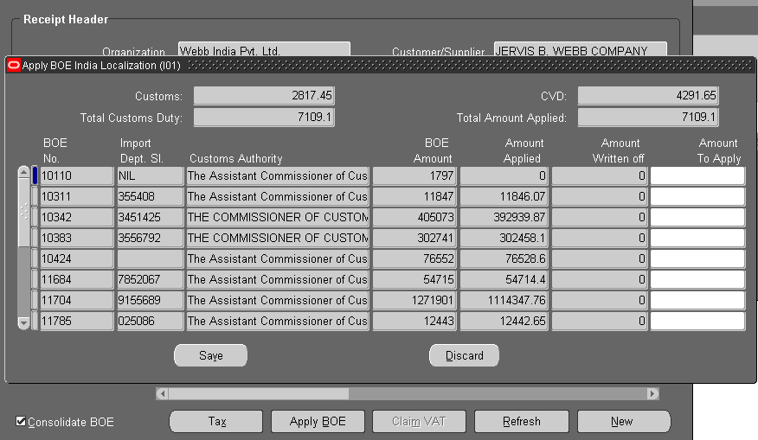

- Inspect: This process is performed by Quality and is explained in the quality user manual

- Deliver
Deliver step results in getting on hand stock for the items in GRN for material receipts. For OSP Receipts, it triggers the OSP job process and for expense receipts, items get expensed out and do not update any stock.
CHECKS:
- For OSP Receipts, all the component materials of related OSP job are required to be available in the OSP sub inventory and locator mentioned in the OSP job. If they are not available and deliver of OSP receipt is done, OSP job does not consume the components and result in failure of the job.
NAV: WIL India Local Inventory End User Oracle Inventory Transactions Receiving Receiving Transactions
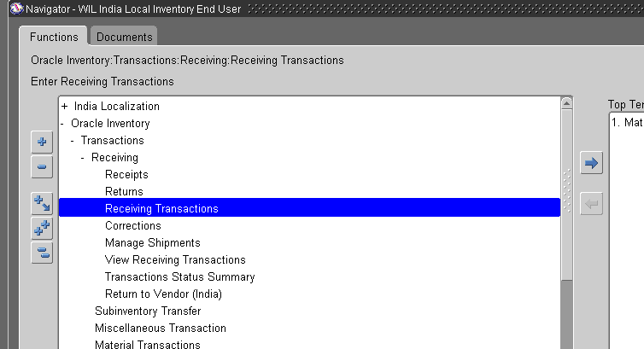

- Enter the receipt number and click on find

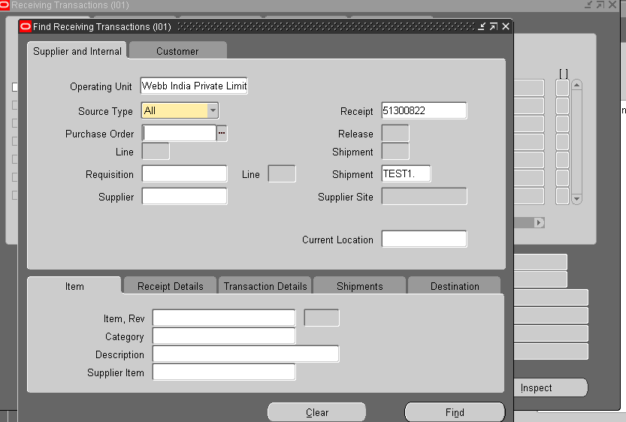
- All the Items in the Receipt are displayed and where ever destination type shows “Inventory”, there are ready for deliver transactions. For Expense items, the destination type will be “Expense “ and for OSP receipts, it will be “Shop floor”.
CHECKS:
- Destination type indicates the type of receipt whether it is Material, expense or Shop floor. In case, any material receipt is showing destination type as “Expense”, you need to cancel the receipt and inform the Purchase Requester to provide the correct destination during Purchase requisition creation because expense destination does not result in stock updation , it gets expensed out as soon as the deliver is complete.
- Parent type shows the status of the QC inspection, the values are accept and reject. If it is showing Accept, it should be stored in RM stores and if it is Reject, it should be kept in Rejection stores.
- Project and task in the locator will get defaulted from the Purchase order, we should not change the default values and if we try to enter any other project, system does not allow and throws error.
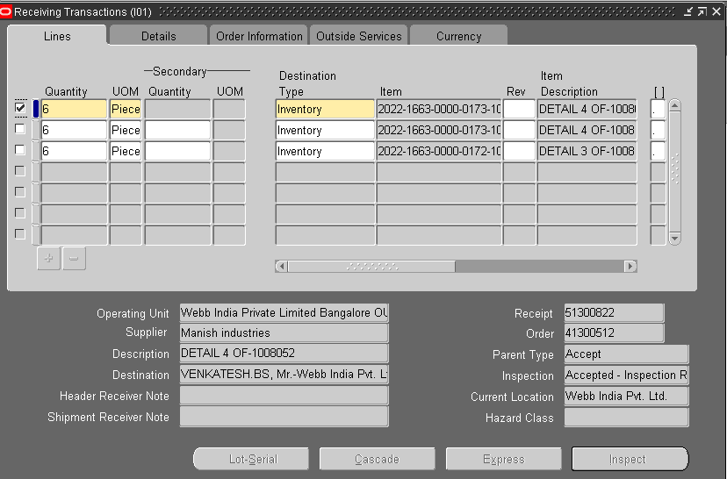
- Select the items to be delivered and enter the Sub inventory and locator information.
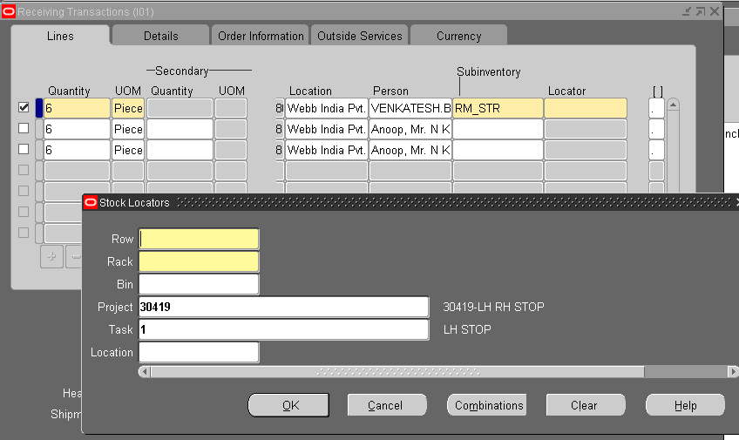
- Continue to select all the lines in the receipt , enter the subinventory and locator and save.
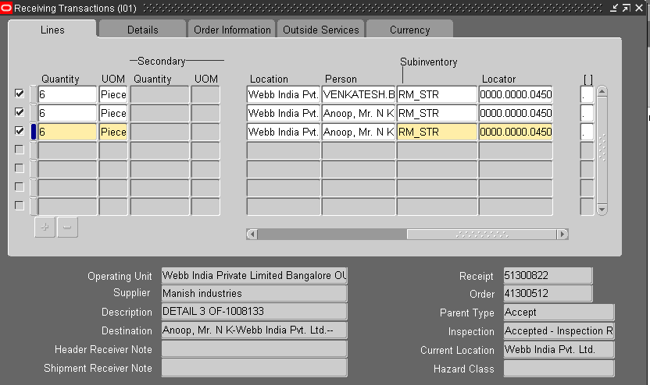
- EXPENSE RECEIPTS: For Expense items, destination is displayed as Expense as shown below and it does not ask for sub inventory and locator. When saved expense item, system does not update any stock. For service receipts, we will have the expense destinations.

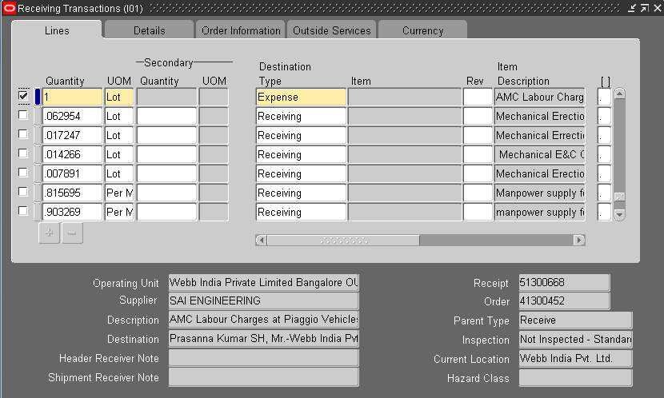
- OSP RECEIPTS: OSP receipt will have the destination type as shop floor. Saving the OSP receipt here will not update any stock, it triggers the OSP job process.
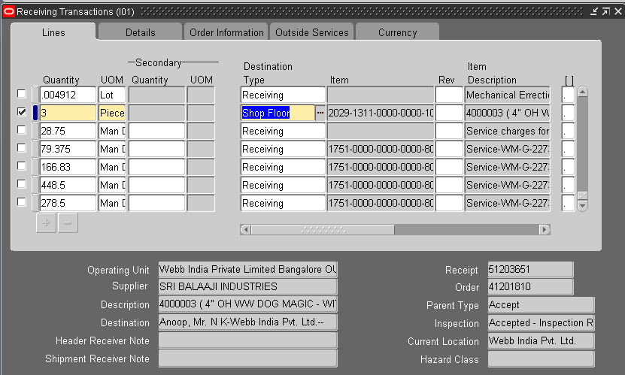
- Once the Receipt process is complete, we can take the report for the GRN using the report name : WIL Goods Receipt Note:
NAV: View Requests submit new Request
Enter parameter receipt number and submit, click on view output and select Browser as viewer option and check the output.
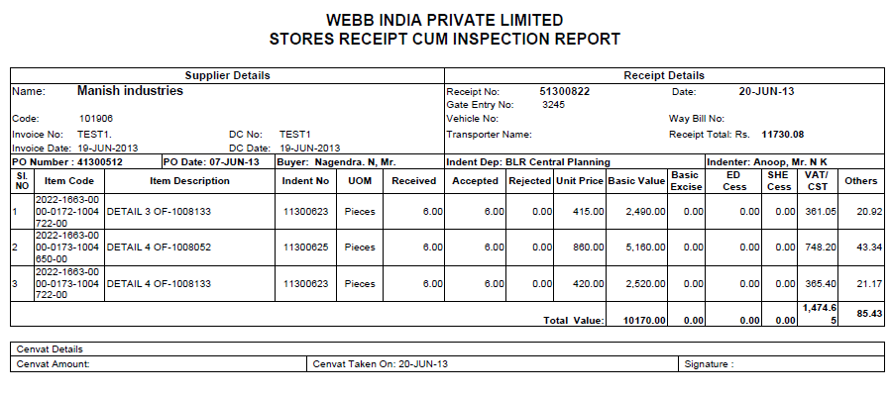
- There are two more reports available for the GRN view , they are
- WIL Deliver Details Report
- WIL GRN Report

